brat Autopilot Configuration R2025a
Created and Maintained by Garrett Asper garrettasper@vt.edu and Patrick Corrigan patrickcorrigan@vt.edu

PX4 Repository Setup

Setting up the Windows-Linux (WSL) Toolchain
These procedures are to install WSL - Ubuntu 22.04.3 LTS
These steps were revised and validated over several installations on different devices running Windows 11. These steps come without warranty nor guarantee of success.
In the command prompt as the administrator, run
wsl.exe –install
If this does not successfully install the program, a series of steps to enable virtualization will need to be performed as the administrator in PowerShell
dism.exe /online /enable-feature /featurename:Microsoft-Windows-Subsystem-Linux /all /norestart
dism.exe /online /enable-feature /featurename:VirtualMachinePlatform /all /norestart
Enable-WindowsOptionalFeature -Online -FeatureName VirtualMachinePlatform -NoRestart
Then, restart the computer, and run the same three commands again as the administrator in PowerShell
Note: The fourth command will change the version of WSL to version 2
dism.exe /online /enable-feature /featurename:Microsoft-Windows-Subsystem-Linux /all /norestart
dism.exe /online /enable-feature /featurename:VirtualMachinePlatform /all /norestart
Enable-WindowsOptionalFeature -Online -FeatureName VirtualMachinePlatform -NoRestart
wsl --set-default-version 2
Then, close PowerShell and open the command prompt (not as the administrator) and run
wsl --update
wsl.exe --install Ubuntu
Then, the user will be prompted to enter a username and password for use when performing root operations with WSL.
Then, search for WSL in the windows search bar
In WSL, send the following commands
sudo apt update && apt upgrade
WSL will then prompt the user for the password setup for root operations in the previous step. Now the PX4 repository can be cloned.

Cloning the PX4 Repository
Open the WSL application and send the following commands
(where <px4_repo_name> is the name of the folder your repository will be cloned under)
mkdir <px4_repo_name>
cd <px4_repo_name>
git clone https://github.com/PX4/PX4-Autopilot.git --recursive

This step will take a while to clone the repository. Once it is done and while in the directory of the <px4_repo_name>, enter the following commands
cd <px4_repo_name>
git checkout v1.14.3 -f
git submodule update --init --recursive
cd Tools/setup
bash ./ubuntu.sh
The bash command will require root access (so the password for sudo) if it has not already been entered in this session of using the WSL terminal. After the setup process completes, restart your device.

The next steps will take place in the hardware setup screens in MATLAB.

UAV Toolbox Setup

Installing the Right Programs
The following programs are needed for the UAV Toolbox – PX4 toolchain
- MATLAB
- Simulink
- MATLAB Coder
- Simulink Coder
- Embedded Coder
- UAV Toolbox
- UAV Toolbox Support Package for PX4 Autopilots
- WSL
- QGroundControl (v. 4.4.2)
- MissionPlanner (for CubePilot drivers)
- RFDTools (v2.67)
- DroneCAN GUI Tool (if using UAVCAN v0 (DroneCAN) ESCs)

[Initial] Building the PX4 Base Code with the Hardware Setup Screens
The following instructions serve as steps to walk through the first time going through Hardware Setup screens. The windows below will only appear in this order when setting up a new device with the toolchain. After this initial PX4 Base Code build, the user will refer to the “[Recurring] Building the PX4 Base Code…” section below.
In MATLAB, navigate to Add-Ons > Get Add-Ons
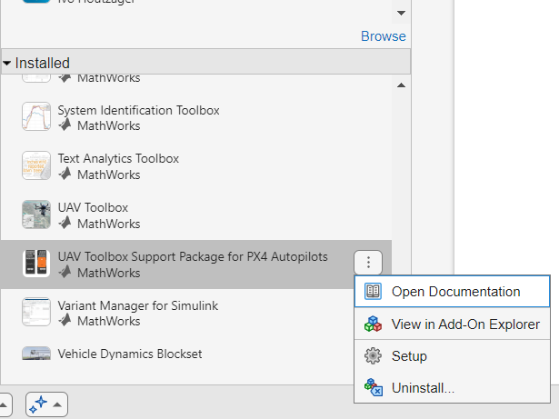
Search for “PX4 Support Package” and install the “UAV Toolbox Support Package for PX4 Autopilots”

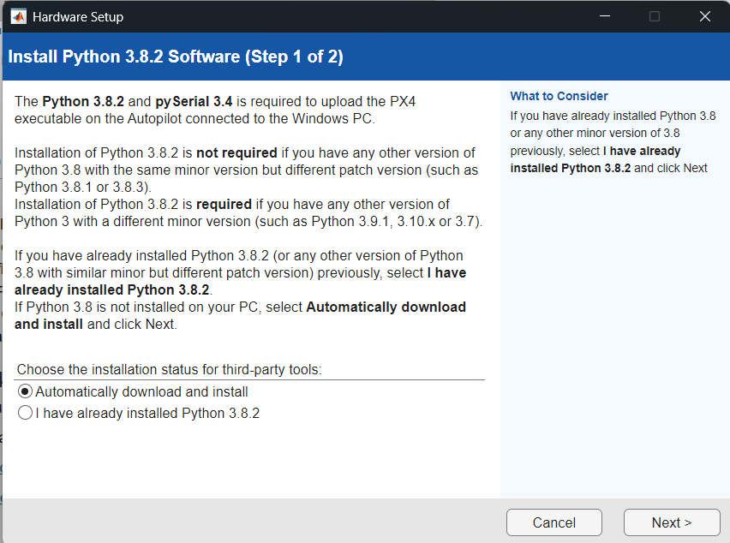
Select “Automatically download and install” and then click “Next”

Click “Install” and then “Next” once the installation is complete
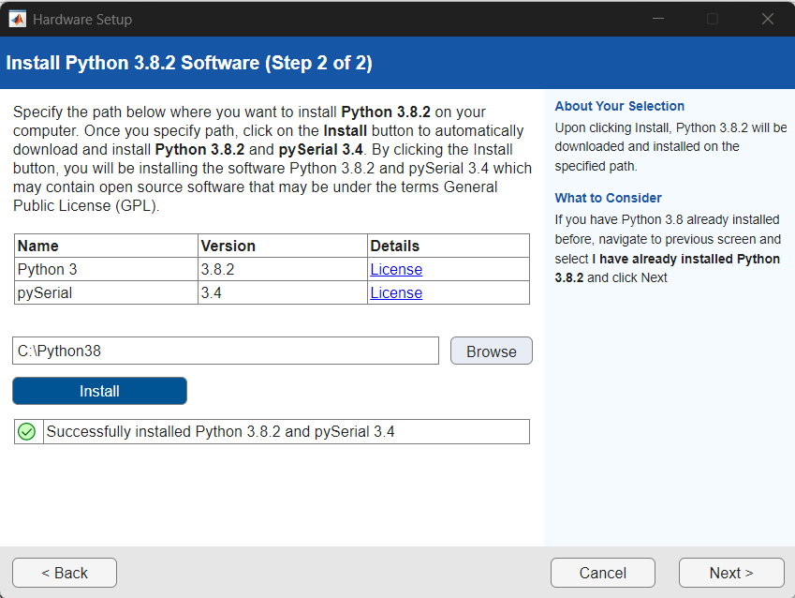
Next, download the PX4 Source Code following the steps in PX4 Repository Setup
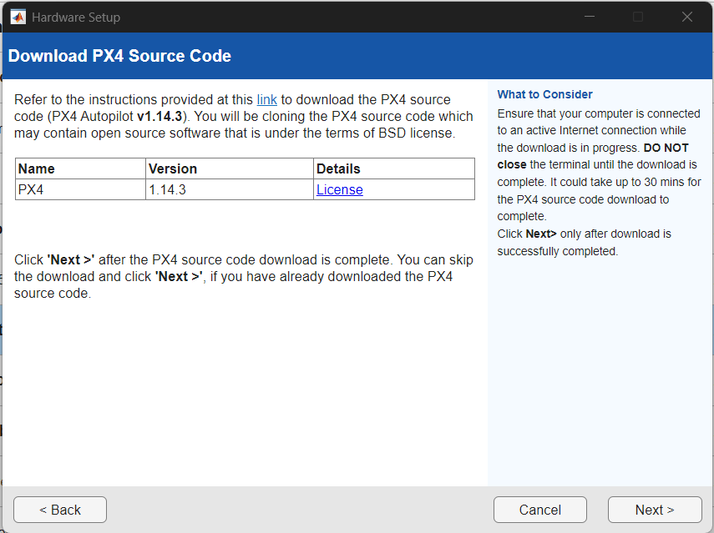
Follow the steps available on this page for steps on how to install the PX4 v.1.14.3 Firmware
https://www.mathworks.com/help/releases/R2025a/uav/px4/ug/downloading-px4-source-code-wsl2.html
Alternatively, follow these steps (validated):
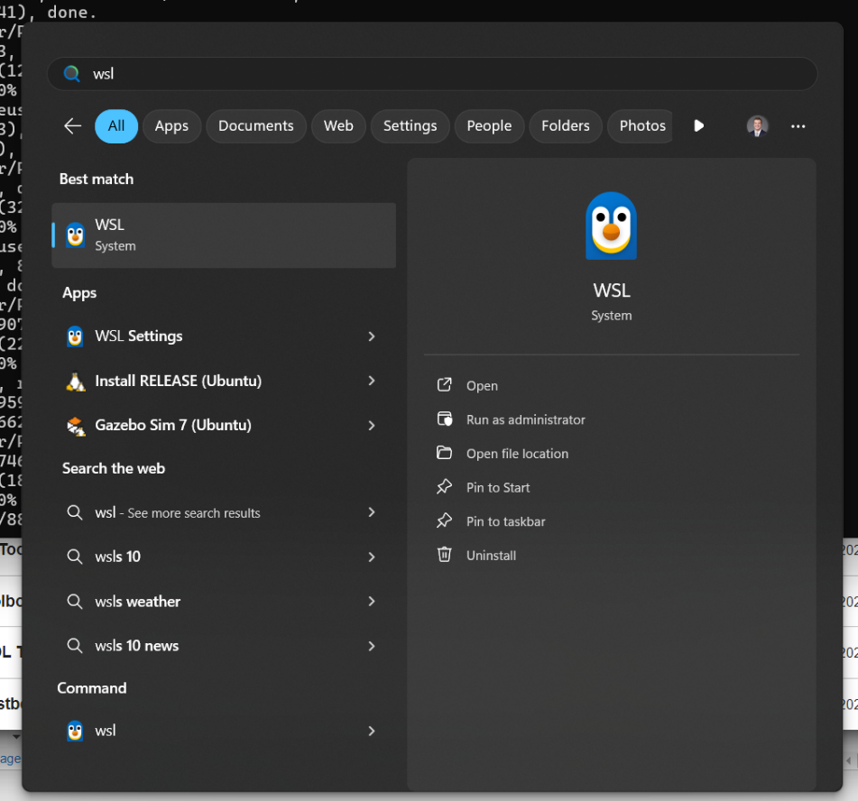
Hit the windows key, and search “WSL” and launch this command window

In the WSL terminal, paste and run the following one at a time
mkdir <px4_repo_name>
Note: <px4_repo_name> will refer to the name of the folder in which you clone the files for PX4. The user retains the option to keep different modified versions (i.e., for various vehicles, custom parameters, etc.)
cd PX4-Autopilot
git clone https://github.com/PX4/PX4-Autopilot.git --recursive
Let the download complete. It may take several minutes.
git checkout v1.14.3 -f
git submodule update --init --recursive
The last command may take a few minutes.
Next, run these commands to ensure the correct version has been cloned.
git describe --tags
The output returned should be: v1.14.13
Return to the Hardware Setup screens. Then click Next
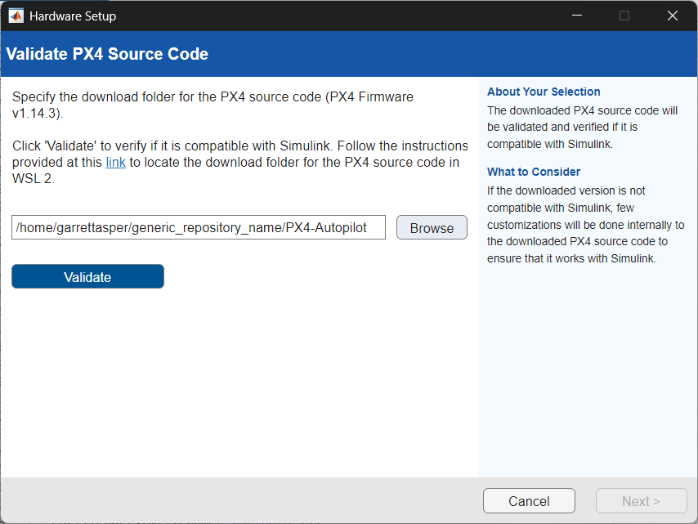
Click “Validate” to have MATLAB validate the source code cloned.

Once validated, click “Next”
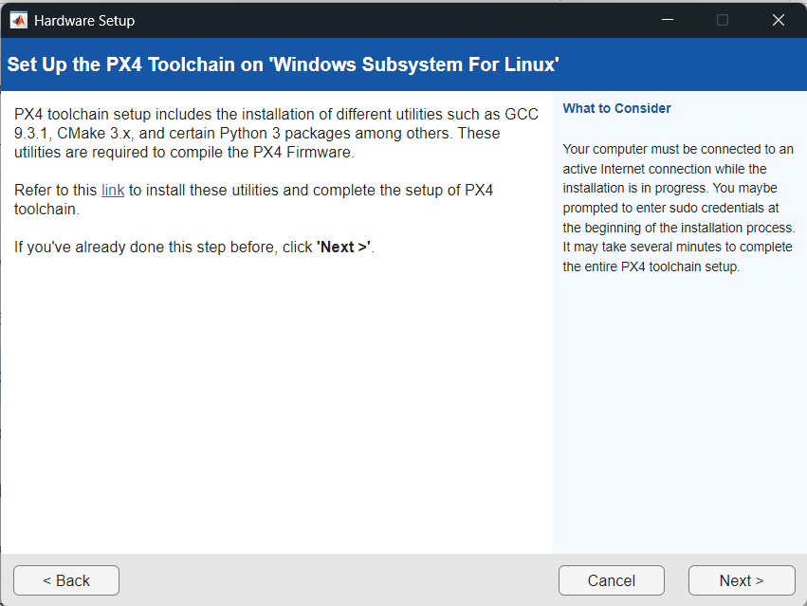
Click the link on this screen, or use this link directly as shown in the image below: https://www.mathworks.com/help/releases/R2025a/uav/px4/ug/setup-px4-toolchain-wsl.html
Follow the steps available on the webpage
Alternatively, follow these same steps below (validated)
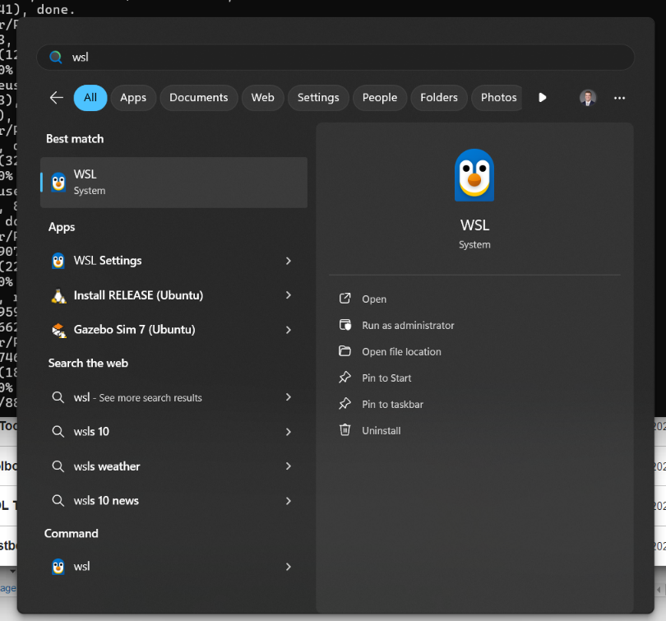
Hit the windows key, and search “WSL” and launch this command window

Run the following commands one at a time to access the directory in which the PX4 source code was cloned
cd ~
cd PX4-Autopilot
cd Tools/setup
bash ./ubuntu.sh
Now, the WSL terminal will prompt you for your Unix credentials determined during the WSL2 setup process. Enter those when prompted.
The PX4 source code will be reconfigured. Close the WSL terminal once the process is finished.
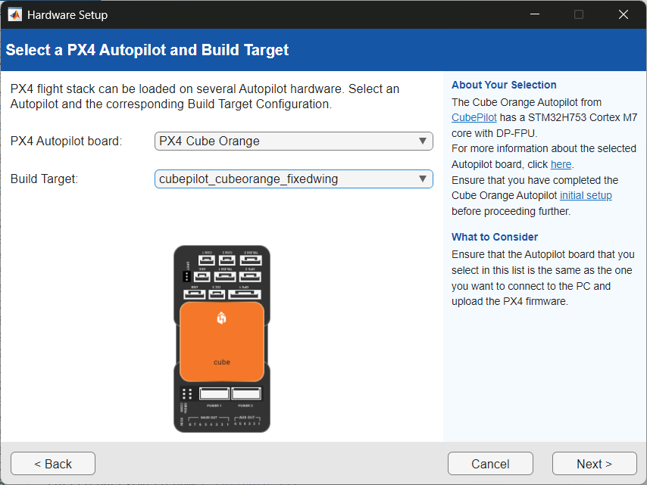
Return to the Hardware Setup screens, and click “Next”
Select the appropriate PX4 Autopilot board and Build Target. The “PX4 Cube Orange+” and “cubepilot_cubeorangeplus_default” were the PX4 Autopilot board and Build Target used for this process, respectively. Click “Next.”
In the next screen, the user will determine whether the PX4 control algorithms are enabled or disabled during the build process. Complete the following actions depending on your use case:
Disable multi-copter and fixed-wing controller modules in PX4 Firmware
- You plan to create a comprehensive control algorithm for testing on a UAV platform.
  - This will require you to create interfaces with Sensors & Pilot Commands -> Your Control Algorithm -> Outputs to the control effectors of the vehicle
Otherwise, uncheck the box if you plan to use the stock PX4 control algorithm for the UAV platform for applications including:
- System Identification
- Running custom algorithms independent of the vehicle control.
- Upstream path or trajectory planning algorithms
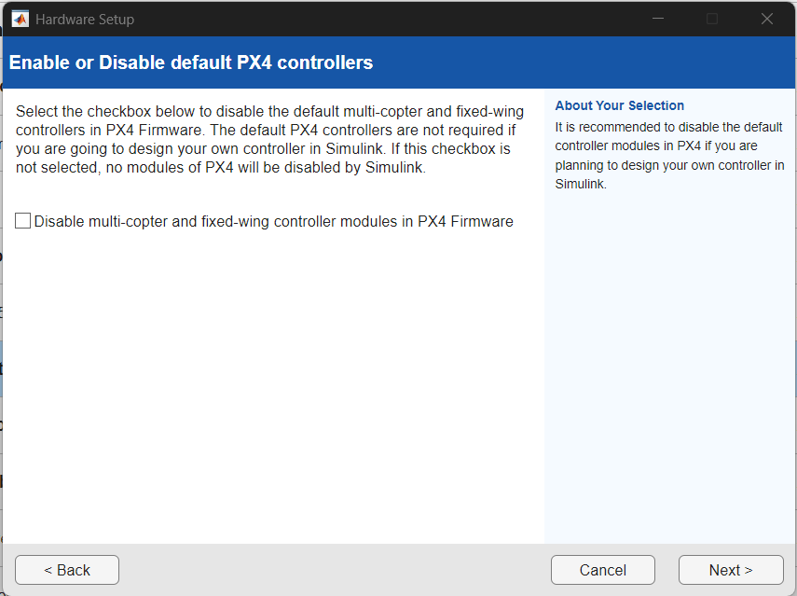
- Other

Click “Next”. Use the default startup script (rcS) unless your application requires otherwise. For most use cases, rcS will work.

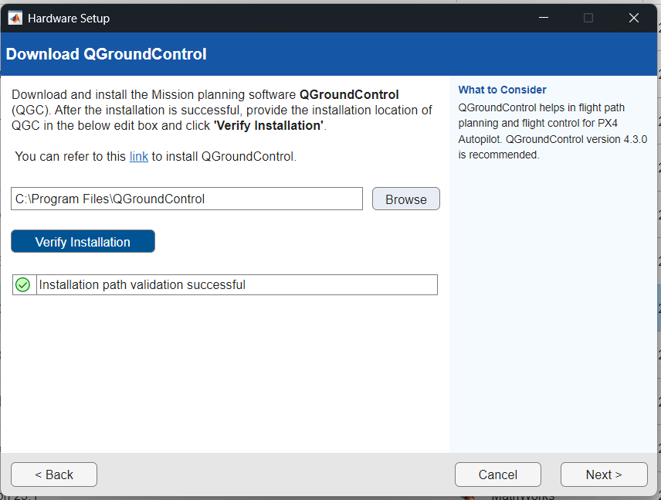
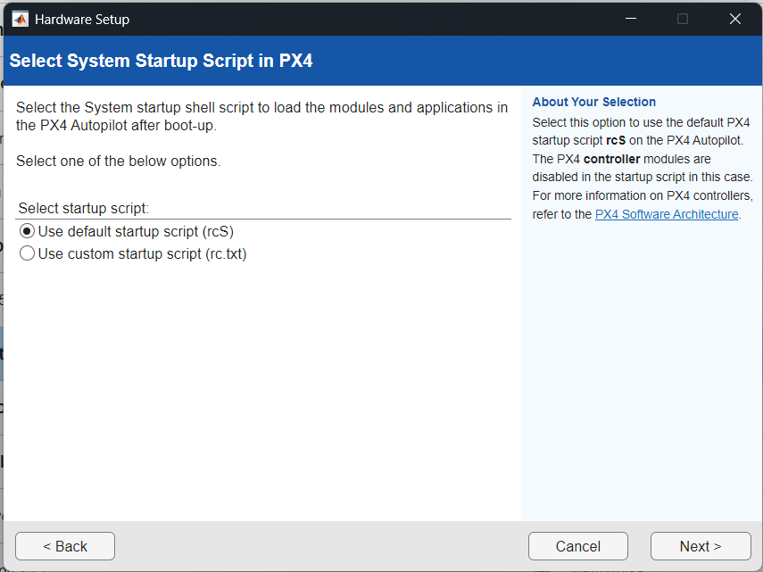
Next, verify QGroundControl installation. Once verified, click “Next.”
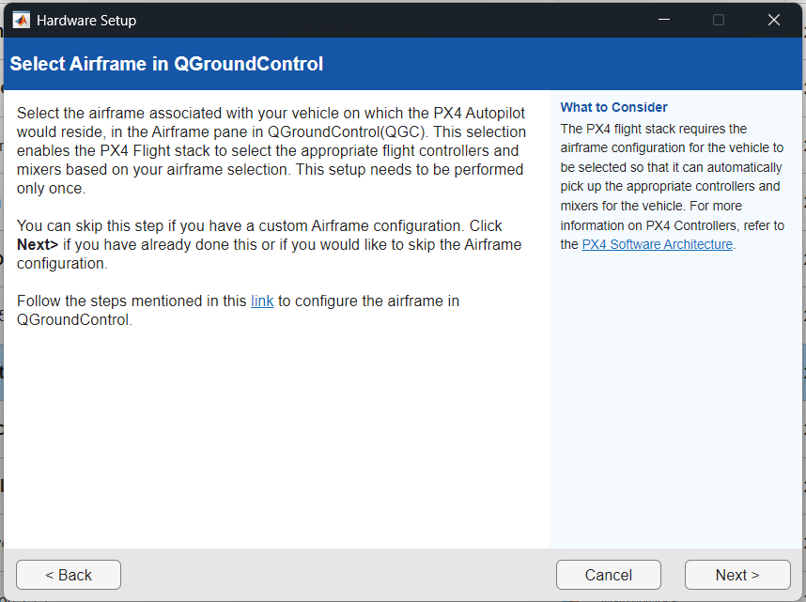
The next screen is more of an advisory. The user can change the airframe they use after proceeding through this screen if required. In other words, click “Next.”

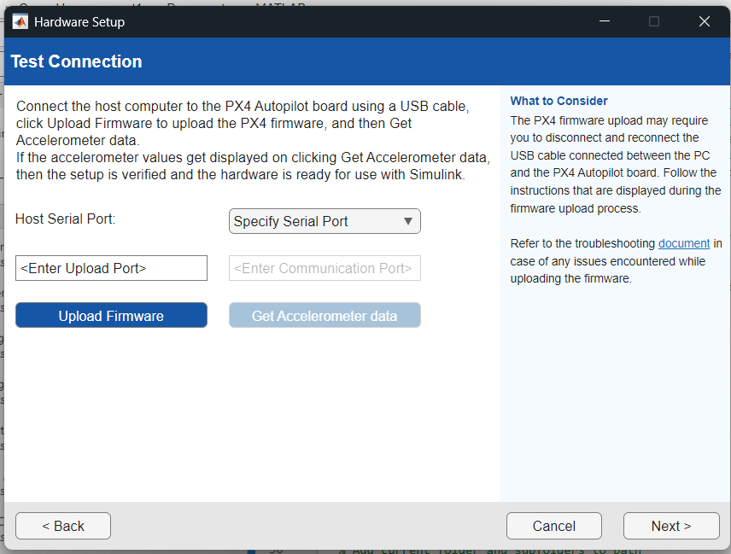
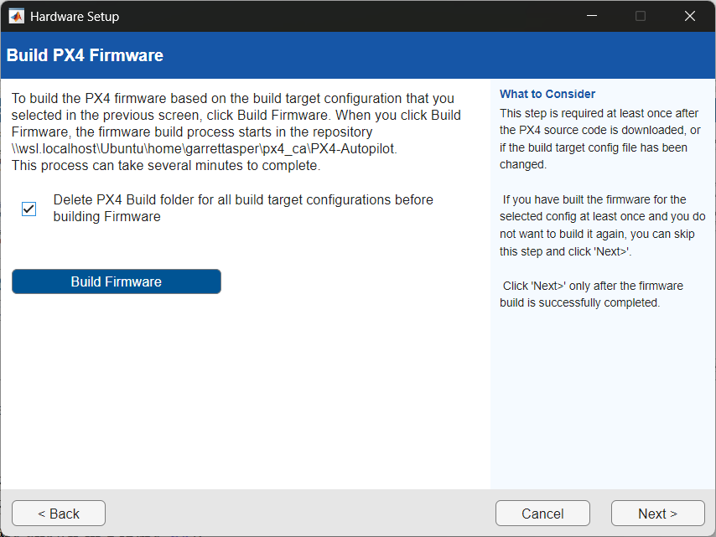
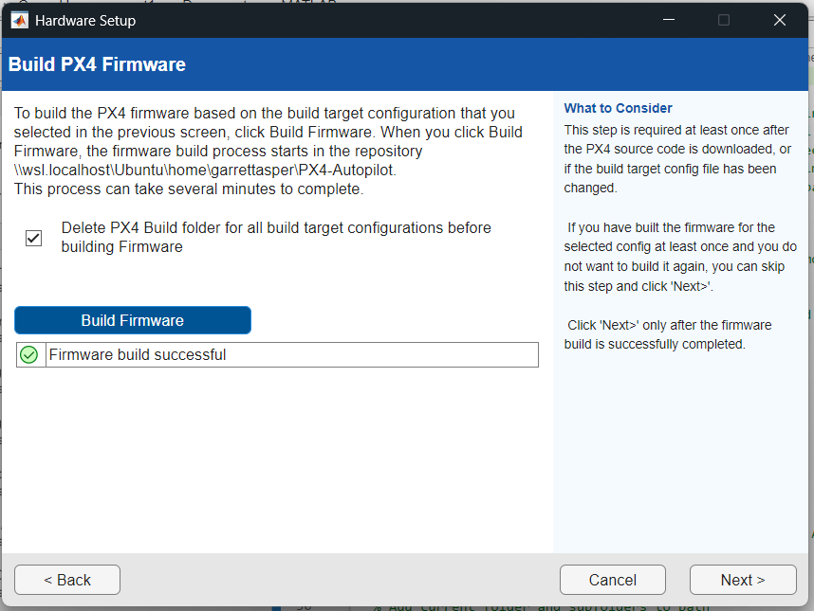
The next screen will prompt you to build the PX4 firmware for the autopilot. Click “Build Firmware”.
For now, the Hardware Setup screens are unable to detect the bootloader for firmware deployment. As a result, the following steps should be followed at this point.

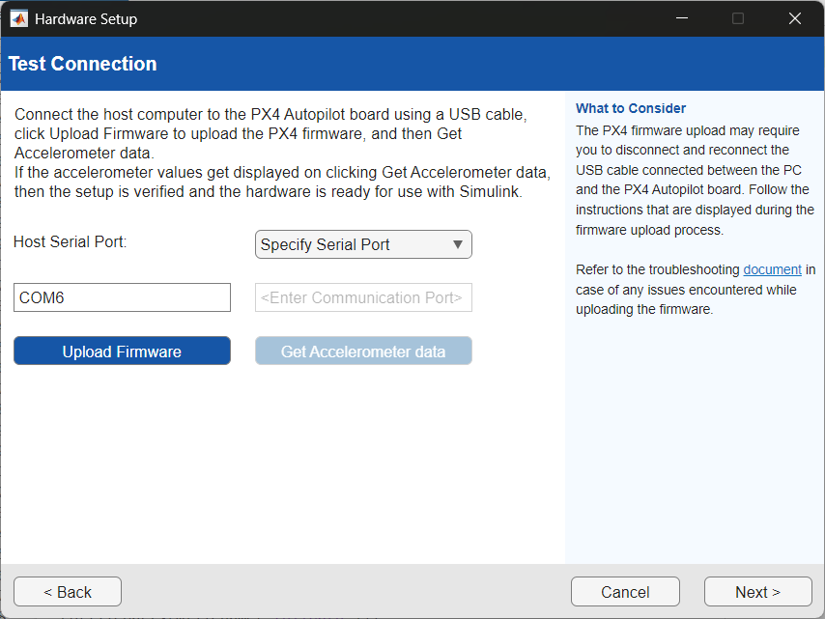
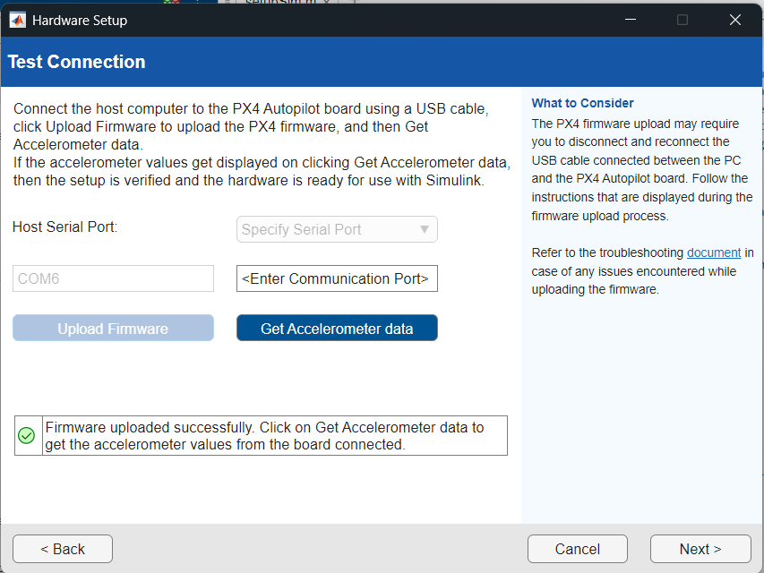
Assuming the user is on the “Test Connection” page of the Hardware Setup Screens, and the target autopilot is disconnected, proceed as follows. There is a field to specify the COM port of the target autopilot’s bootloader. To find the port, hit the Windows key, and search for/open the “Device Manager.” Once the “Ports” section is expanded, plug in the target autopilot using a USB cable. The following should appear initially, where the device that first appears is the bootloader COM port. Note this port number, as in the case of this demo, it is “COM6.”
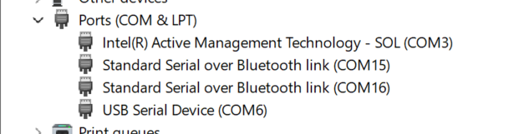
The user will notice that after ~5 seconds, the port will change. This is expected. This is referred to as the communications port. In the case of this demo, it is “COM7.” Now, unplug the autopilot and leave it unplug until prompted to plug it back in in this tutorial.
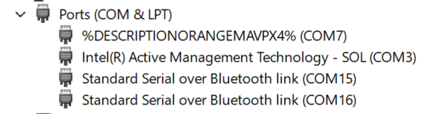
Return to the Hardware Setup Screens, and enter the bootloader COM port (“COM6” on the demo computer). Then click “Upload Firmware”. The following screen will appear
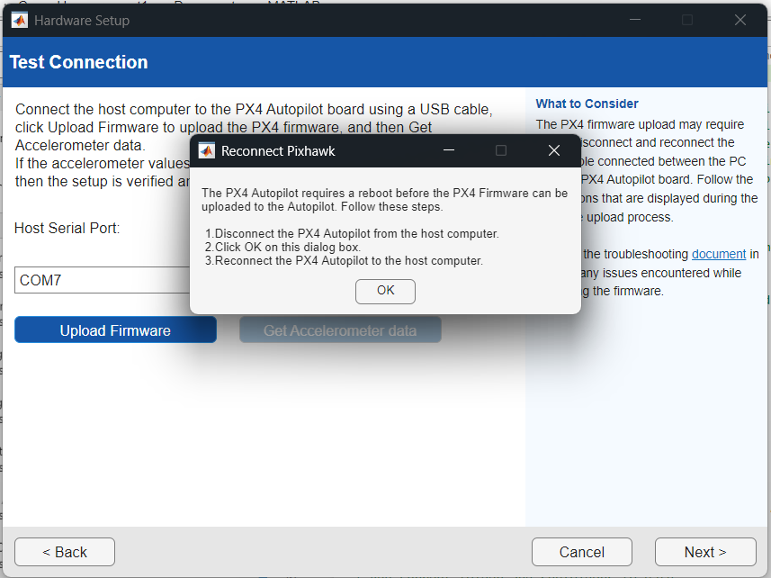
At this time, click “OK” and then quickly plug in the target autopilot. At this point, the Command Window should begin printing the firmware deployment progress as shown below.
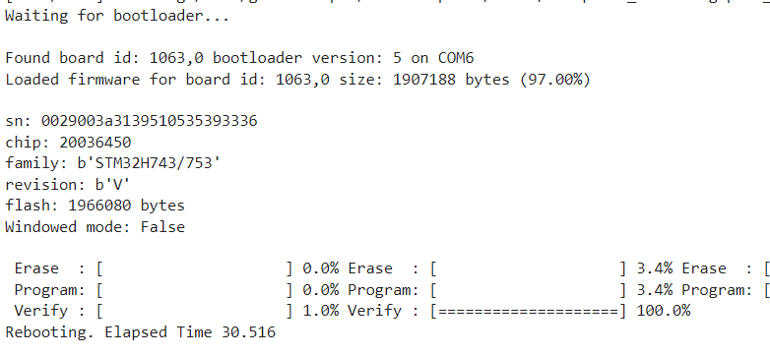
Once the build is complete and the green checkmark appears on the “Test Connection” screen, skip the “Get Accelerometer Data” step, and click “Next.”
Congratulations, the hardware setup process is complete.
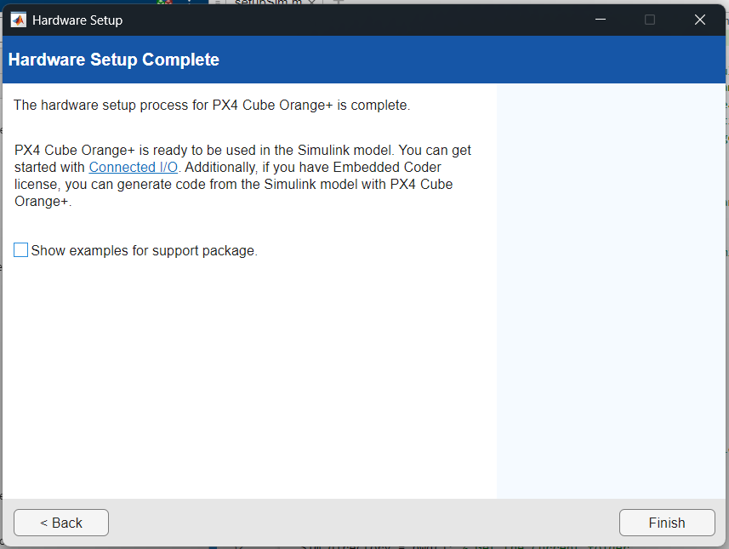

[Recurring] Building the PX4 Base Code with the Hardware Setup Screens
The following instructions serve as steps to walk through the Hardware Setup screens.
Note: These steps must be completed before making any custom modifications to the source code (as described in the PX4 Firmware Modifications section) and again after the modifications are complete.
Consult the [Initial] Building the PX4 Base Code with the Hardware Setup Screens section, as R2025a does not differ in an initial or recurring build.

PX4 Firmware Modifications
All modifications described in this section must be made in the PX4 base-code repository created. The general path is \Linux \Ubuntu\home\<wsl_username>\<px4_repo_name>
These modifications must be made to enable the full functionality of a brat vehicle.
Note: Any modification to the base code of PX4 requires that the user completes the Hardware Setup screens again to rebuild the repository.
Quick Start
All files necessary to modify PX4 for the VTPACT are available in folders corresponding to their subsection titles. Look for the Quick Start textbox in each section to see what files to place in the PX4 repository and where they should go.

Logging

Firmware Changes
Quick Start
Place the FcsSignals.msg in the following path
<px4_repo_name>\msg
Replace the current version of the CMakeLists.txt file on the following path with the version under version control
<px4_repo_name>\msg
Detailed Setup
To log signals internal to the Simulink diagram to a ULog topic in PX4, some modifications need to be made to the PX4 base code.
First, a new file called FcsSignals.msg must be placed in the following path:
<px4_repo_name>\msg
This file contains vectors corresponding to data topics within the FcsSignals message.
For example:
float32[3] attitude
Allocates a 3x1 vector named ‘attitude’ within the FcsSignals message.
Finally, the name of the custom message, in this case FcsSignals.msg, must be added to the CMakeLists.txt file under the following path:
<px4_repo_name>\msg\CMakeLists.txt

SD Card Changes
Quick Start
Place the logger_topics.txt in the following path on the SD card used in the Pixhawk
etc\logging
Note: If the directory above does not yet exist on the card, make it.
Create the directory on the SD card used in the Pixhawk Autopilot:
etc\logging
In the logging folder, create a logger_topics.txt file, or use the logger_topics.txt file available in the repository under
<px4_repo_name>\hardware_setup\Logging\SD Card
And place it in the path created above on the SD Card
Note: the following line should be inserted to ensure the fcs_signals logger topic is logged
fcs_signals 0
Below is an example of the logger_topics.txt contents used on the CZ150 for System Identification
More information is archived at: https://github.com/NSL-VT/PX4_Custom_Data_Logging/tree/main
actuator_motors 0
actuator_servos 0
battery_status 1000
cpuload 1000
distance_sensor 20
estimator_states 0 0
estimator_sensor_bias 1000 0
fcs_signals 0
home_position 10000
input_rc 0
sensor_combined 0
sensor_gps 0
sensor_mag 0
logger_status 1000
vehicle_air_data 100
vehicle_angular_velocity 0
vehicle_attitude 0
vehicle_attitude_setpoint 20
vehicle_control_mode 1000
vehicle_local_position 0
vehicle_local_position_setpoint 20
vehicle_rates_setpoint 20
vehicle_status 1000
yaw_estimator_status 100 0

Telemetry
Quick Start
Place the mavlink_main.cpp file on the following path
<px4_repo_name>\src\modules\mavlink
More Details
A custom telemetry stream can be enabled through the existing DEBUG_FLOAT_ARRAY MAVLink message.
To enable the DEBUG_FLOAT_ARRAY, navigate to the mavlink_main.cpp file under the following path
<px4_repo_name>\src\modules\mavlink\mavlink_main.cpp
In the code, under the case MAVLINK_MODE_NORMAL , make the following changes
configure_stream_local("ATTITUDE", 12.0f);
configure_stream_local("ATTITUDE_QUATERNION", 5.0f);
Add the following line between configure_stream_local("COLLISION", unlimited_rate); and configure_stream_local("DISTANCE_SENSOR", 0.5f);
configure_stream_local("DEBUG_FLOAT_ARRAY", 10.0f);
Under the cases MAVLINK_MODE_NORMAL, MAVLINK_MODE_ONBOARD, MAVLINK_MODE_ONBOARD_LOW_BANDWIDTH, and MAVLINK_MODE_EXTVISIONMIN for the section with the if statement that checks for CONSTRAINED_FLASH condition, delete the following line:
configure_stream_local("DEBUG_FLOAT_ARRAY", 1.0f);
Add the following line under the case MAVLINK_MODE_CONFIG to enable the DEBUG_FLOAT_ARRAY while connected to the autopilot over USB
configure_stream_local("DEBUG_FLOAT_ARRAY", 50.0f);
Under the if statement that checks for the CONSTRAINED_FLASH condition for the case MAVLINK_MODE_CONFIG, delete the following line
configure_stream_local("DEBUG_FLOAT_ARRAY", 50.0f);

Flash Memory
Quick Start
Place the default.px4board.original file on the following path
<px4_repo_name>\boards\cubepilot\<pixhawk_board_name>
Note: This file is only valid for the default build target for the Cube Orange or Cube Orange+
More Details
The following modifications were made to free up flash memory on all three of the build targets in the repository (the three build targets being fixedwing, multicopter, and default).
Navigate to the following file path:
<px4_repo_name>\boards\cubepilot\<pixhawk_board_name>\<build_target>.px4board.original
Where <pixhawk_board_name> is either the cubeorange or cubeorangeplus and <build_target> is either default, fixedwing, or multicopter. For the case of the VTPACT, the default build target was used.
Disable the following modules by changing the ‘=y’ to ‘=n’
CONFIG_DRIVERS_CAMERA_CAPTURE=n
CONFIG_DRIVERS_CAMERA_TRIGGER=n
CONFIG_COMMON_DISTANCE_SENSOR=n
CONFIG_DRIVERS_DSHOT=n
CONFIG_COMMON_OPTICAL_FLOW=n
CONFIG_MODULES_CAMERA_FEEDBACK=n

Enabling RPM Sensor
boards/cubepilot/cubeorange/default.px4board
or the fixedwing.px4build.original

After the irlock one

CONFIG_DRIVERS_RPM_PCF8583=y
Parameters:

50 hz to microseconds (~20000)

In QGC
SENS_EN_PCF8583 – Enable
Reboot

PCF8583_MAGNET 6 (should be num_poles/2)
PCF8583_POOL 20000 us
PCF8583_RESET 500000

Parameters

Custom
Quick Start
Place the module.yaml file on the following path
<px4_repo_name>\src\modules\battery_status
Repository path:
<px4_repo_name>\hardware_setup\Parameters
The Custom_PX4_Parameters.xslx is an excel sheet that contains information about the custom parameters used by the VTPACT FCS. The columns include information including the parameter name, default value, description, data type, parameter group, min, max, decimal places, and a column to check if the value currently on the vehicle differs from the default.
Once the parameters are programmed in the excel sheet as desired, use the generate_yaml.m script to generate a module.yaml file for the PX4 repository.
The current version of the module.yaml file is kept under version control.
This file must be placed in the following path:
<px4_repo_name>\src\modules\battery_status\module.yaml
After placing the yaml file in the file path above, go through the Hardware Setup Screens to build the custom parameters into PX4.
Note: Only custom parameters built as described into the module.yaml file and read in the Simulink diagram through the PX4 Read Parameter blocks will build when the custom firmware is deployed to the flight computer.
Optional: The user has the option to save a .params file to their computer through QGroundControl’s Parameters tab. Then, using the read_params_to_excel.m script, the user can generate a column of the current values of each parameter. By pasting this column into the Custom_PX4_Parameters.xslx, the user can check if the value of the parameter differs from the default setting on the vehicle.
It is recommended that the user sets any parameter values they are satisfied with as the new parameter defaults. This will prevent loss of progress in tasks, including tuning, safety setting defaults, etc.
Finally, the module_original.yaml file should remain unmodified as the generate_yaml.m script relies on it.

Stock
The values set for the stock PX4 parameters are tracked in the Stock_PX4_Parameters.xlsx excel sheet. Ensure these parameters are set as described in the sheet before flight.

QGroundControl Application Settings
All configuration settings described can be completed over a wireless telemetry connection or through a hard-wired USB connection. QGroundControl typically connects to the vehicle through USB automatically, but a wireless, telemetry connection requires configuration described in the next section. Such configuration is required, as when custom parameters are created, the initial data transfer required to load all parameters over a telemetry connection into QGC increases. To increase the capability of the telemetry connection and decrease the time that the initial wireless connection will take, follow the steps below.

Telemetry Ports
Quick Start
If the telemetry radios on the vehicle have been configured, skip to the ‘Connecting through QGroundControl’ subsection

Initial Radio Setup
All brat vehicles use the RFD 900x telemetry radios. Both the radio used by the ground station and the vehicle used must be configured through the RFDTools program.
Launch the RFD900 Tools program, and locate the COM port of the radio that is plugged in via USB. The Baud should be set to 57600 as this is the default rate used in the factory settings. Then, click “Connect”, followed by “Load Settings”.
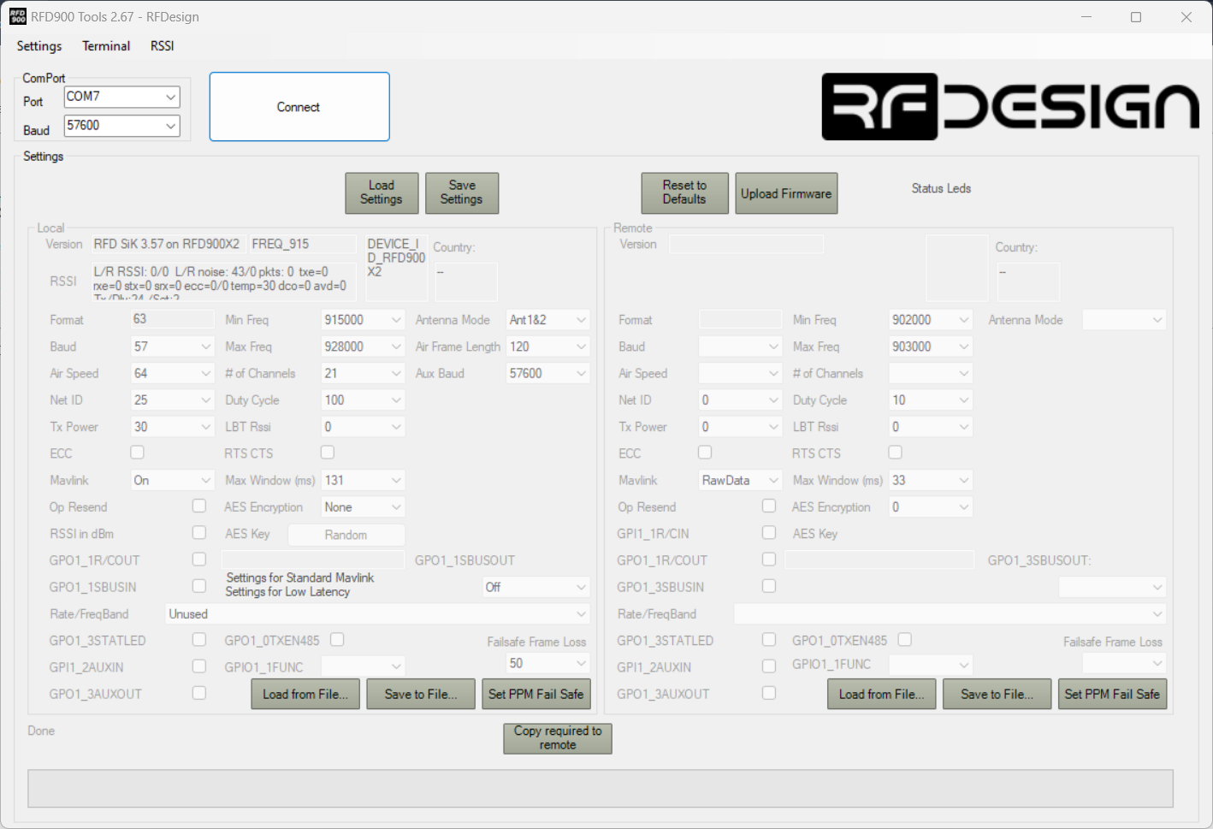
The following parameters need changed
Baud | 115
Net ID | mn (Where m is the vehicle type and n is the vehicle number, i.e., 76 for the CZ-150 6
Tx Power | 30
Air Speed | 96
After these changes have been made, click Save Settings. After about 20 seconds, close the RFDTools program, and relaunch it.
Now, use the same COM port as before, but set the Baud rate to 115200, and click Connect. Click Load Settings, and verify that the changes have taken effect.
Repeat these steps for the matching radio used on the vehicle. Each parameter change will be the same across all radios in the brat fleet, excluding the Net ID, which depends on the vehicle type m and number n.

Connecting through QGroundControl
To be written (describe all the way through getting it working in QGroundControl
Install the FTDI drivers for Windows through the following website:
https://ftdichip.com/drivers/
In QGC, navigate to Application Settings
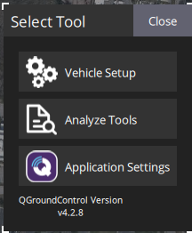
From the tabs in the left, select Comm links, then select Add

New Changes:
Baud: 115200
Air Speed: 64 -> 96

ESC Parameters Castle Link
Braking – 0
Auxiliary White Wire – RPM Out
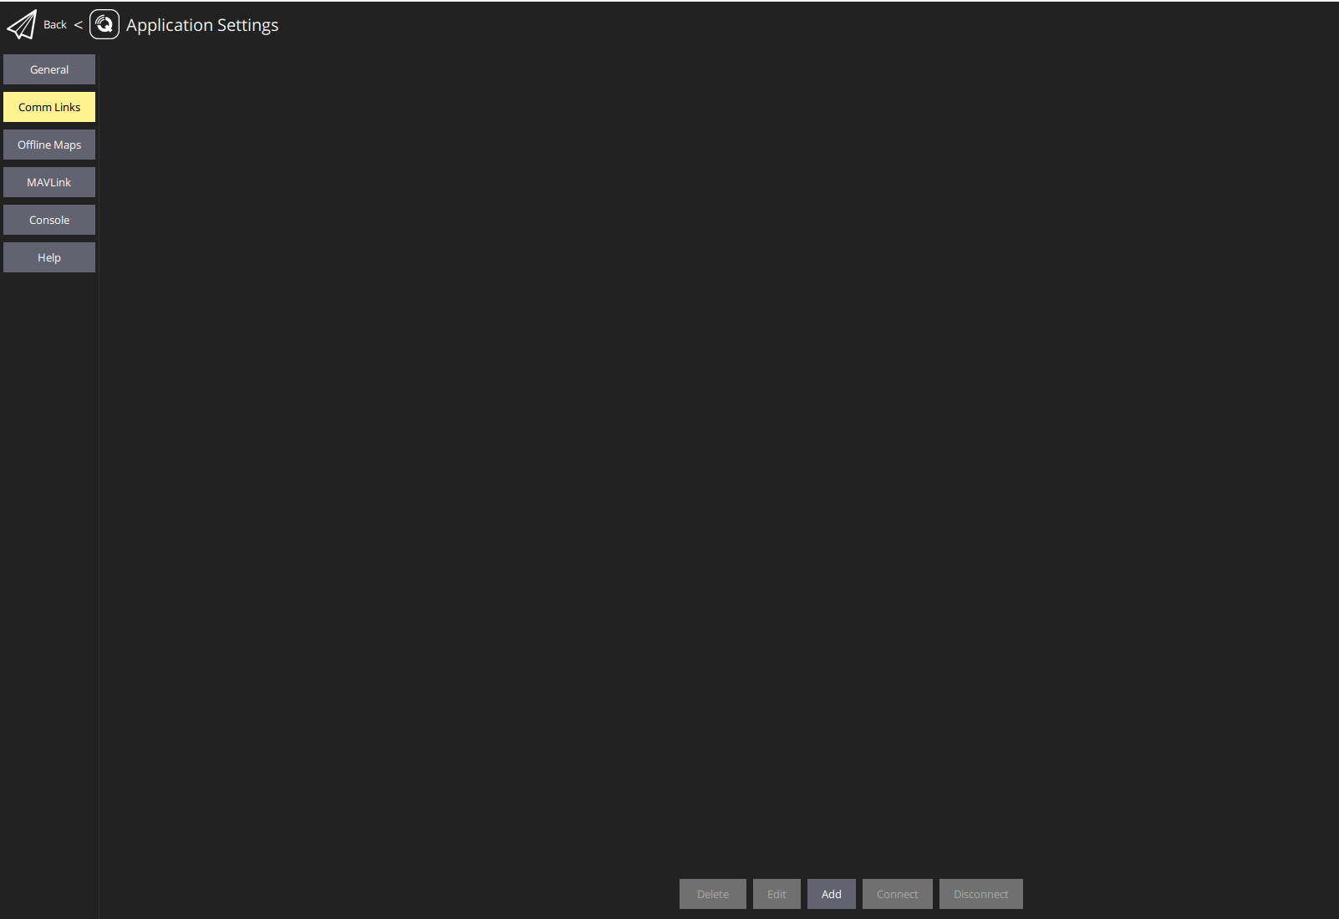
Set up the vehicle Name, select ‘Automatically Connect on Start’, change the COM port to the COM port used by the telemetry radio specific to your computer, and finally set the Baud Rate to 230400.
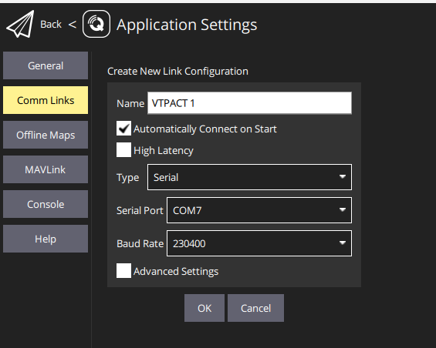
Note: Plug in the radio before launching QGroundControl since the auto-connect feature only checks for the connection when QGroundControl is started.

Custom Ground Control Station
Port forwarding must be enabled in QGroundControl to allow the custom Ground Control Station in Simulink to access the MAVLink signals received from the vehicle. To enable port forwarding, follow these steps.
In QGC, navigate to Application Settings
From the tabs on the left, select MAVLink and check the box next to Enable MAVLink forwarding
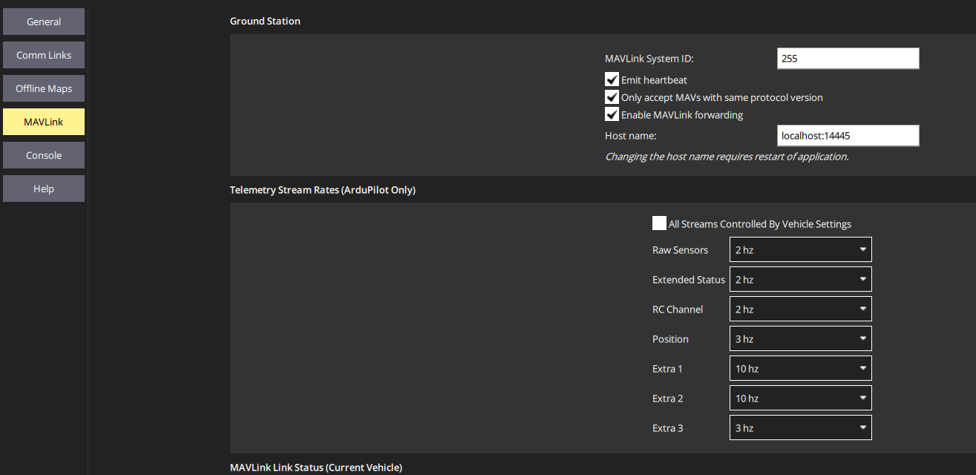

QGroundControl Vehicle Setup
These setup instructions outline the settings necessary for the VTPACT.
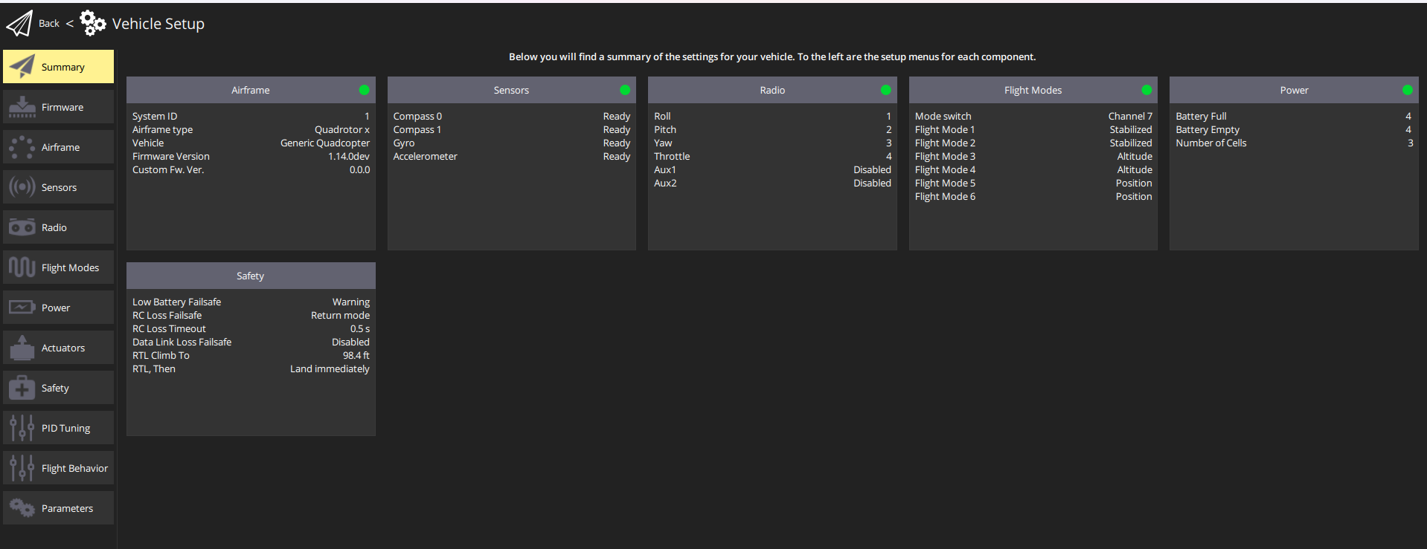

Airframe
The VTPACT uses the Generic Quadcopter airframe. Once this airframe is set, click the apply and restart button for the change to take effect.
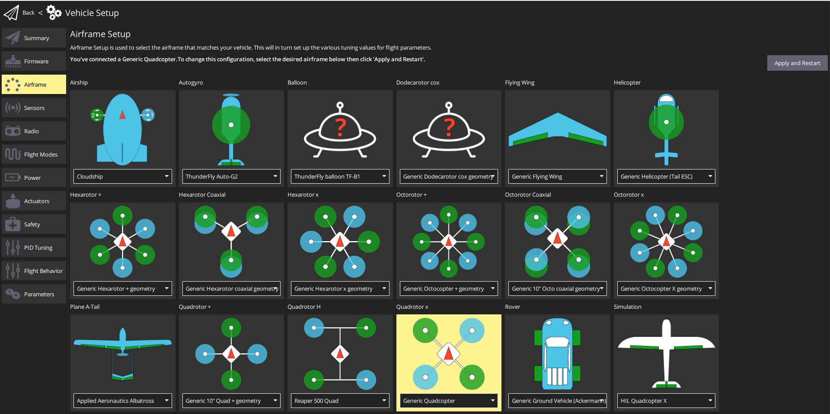

Sensors
The Accelerometer, Gyroscope, and Compass should be calibrated before initial bench testing. Recalibration may be required outside.
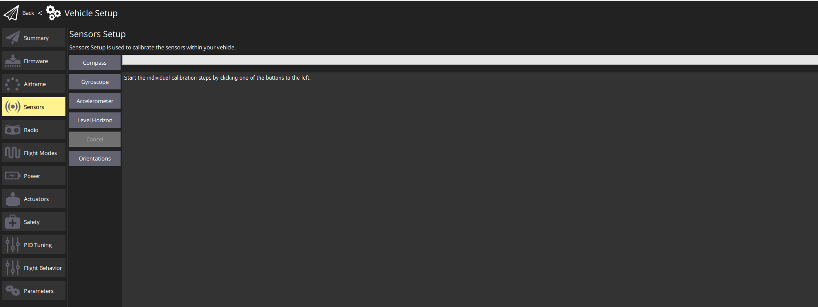

Radio
The radio used for the VTPACT Setup is the Spektrum ix20 with a DSMX protocol receiver. The pair can be bound using the spektrum bind button under the Radio tab. Additional details for the binding process can be found online. When a radio is first set up with a VTPACT, a calibration is required to map the extremes of each stick and switch. QGroundControl walks the user through the orientations to move the transmitter inputs through.
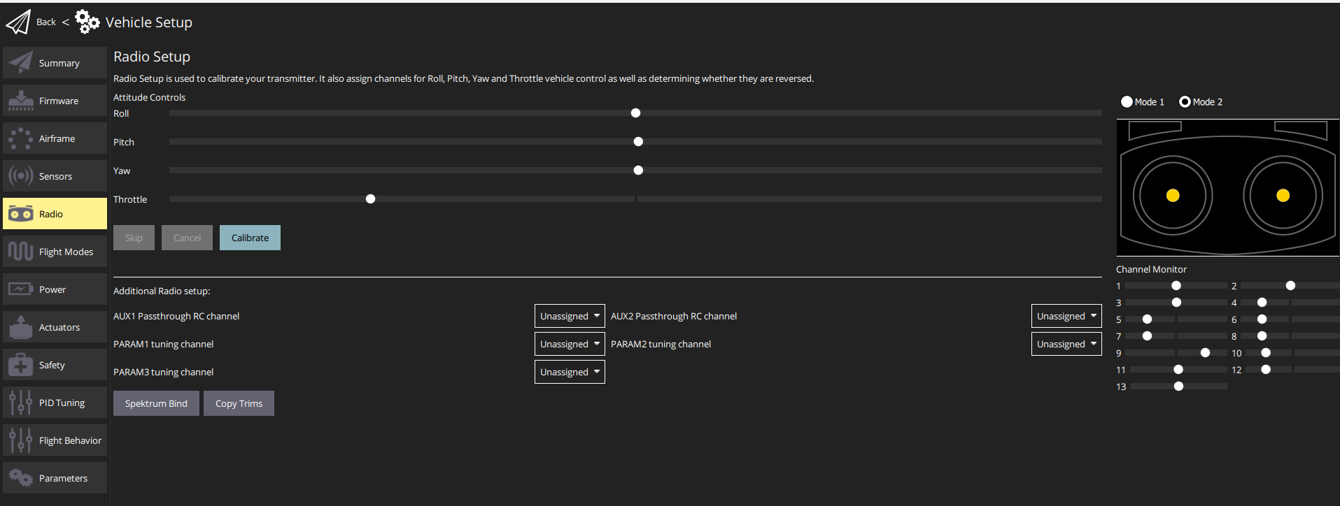

Flight Modes
The flight modes tab allows the user to set switch functions on the transmitter. In the case of the VTPACT, the switches that need set in this menu are as follows
Channel 5 | Arm switch channel
Channel 12 | Emergency Kill switch channel
Channel 7 | Mode Channel

The flight modes should be configured as follows
Flight Mode 1 & 2 | Stabilized
Flight Mode 3 & 4 | Altitude
Flight Mode 5 & 6 | Position
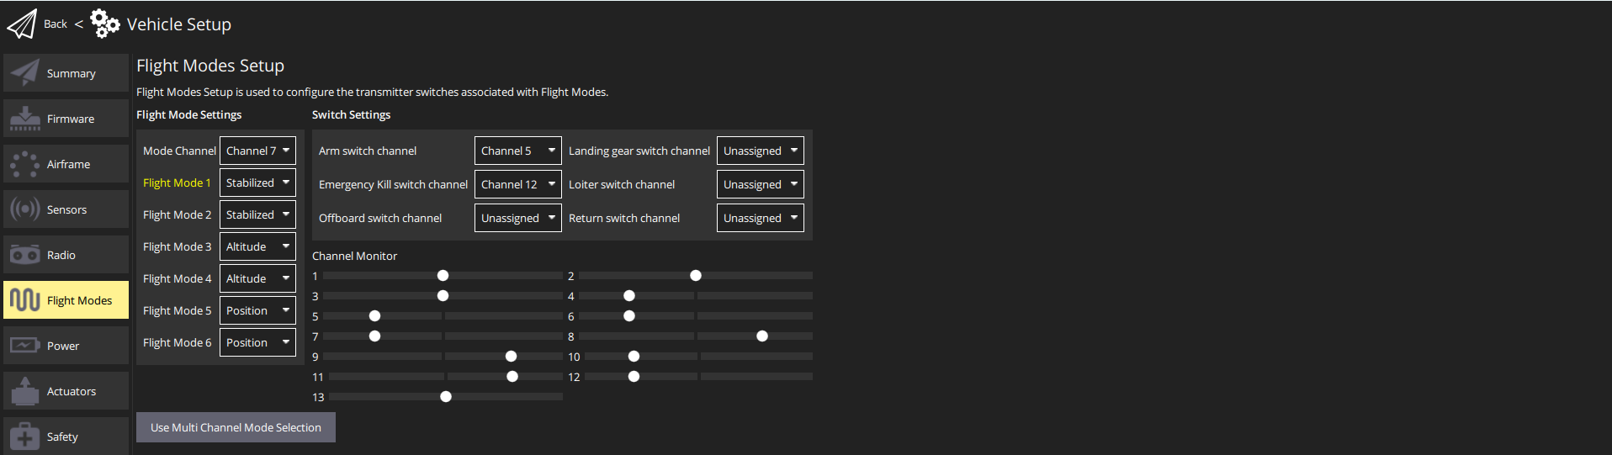

Power
The following parameters must be set for the Power tab
- Source: Power Module
- Number of Cells (In Series): 4
- Empty Voltage (per cell): 3.6
- Full Voltage (per cell): 4.2
- Voltage divider: *Set according to the power module specifications specific to each VTPACT*

Actuators
Under the actuator tab, navigate the UAVCAN panel, and assign the function of ESC 1 – 4 to Motor 1 – 4, respectively. The minimum and maximum values should be set to
Minimum: 376 & Maximum: 8191
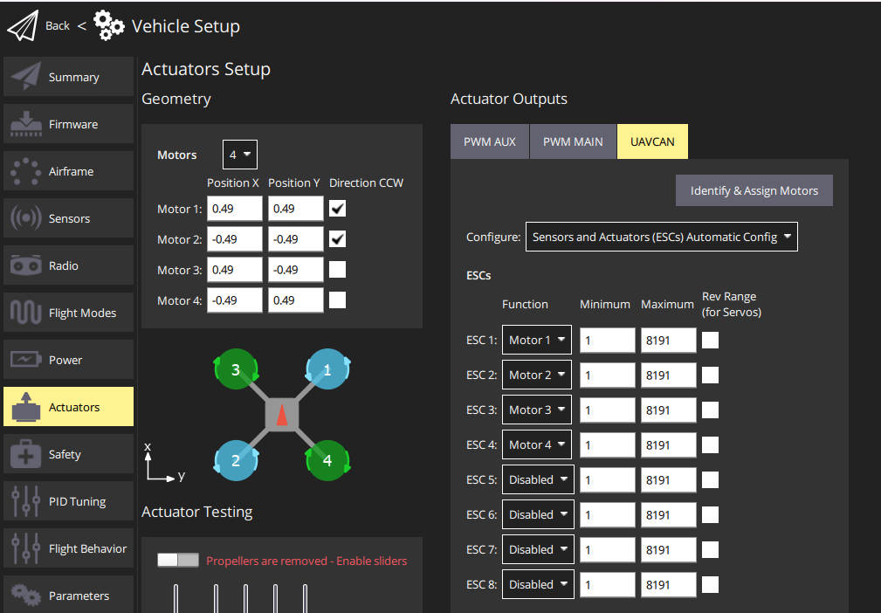

Safety
The safety settings were configured according to the screenshots below
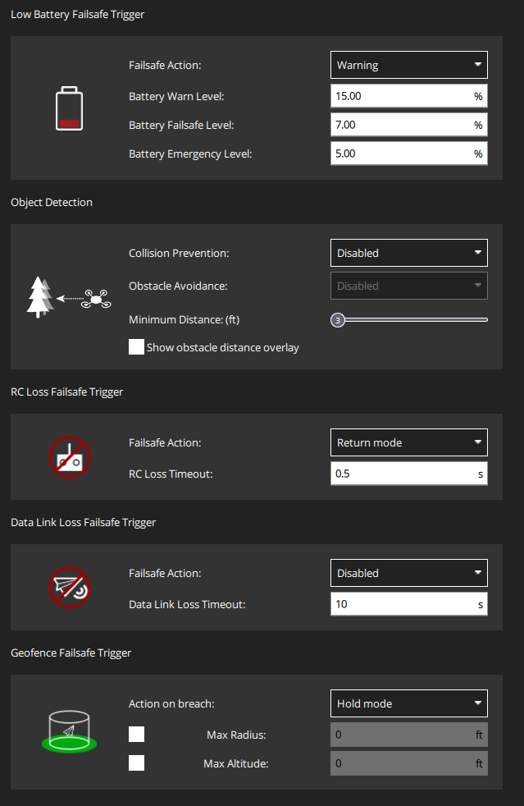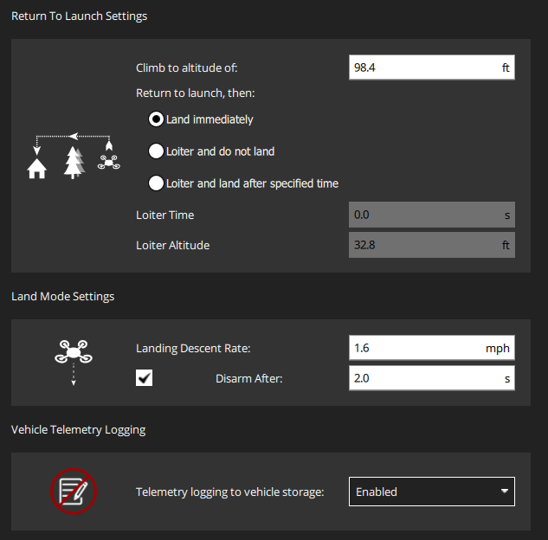

Parameters
The file path below contains two excel sheets used to track the current and most up-to-date parameters used on the VTPACT
<px4_repo_name>\hardware_setup\Parameters
The values set for the stock PX4 parameters are tracked in the Stock_PX4_Parameters.xlsx excel sheet.
The Custom_PX4_Parameters.xslx contains all parameters built for the VTPACT FCS.
Ensure the parameters from both excel sheets are set as described before flight.

